**III.DESIGNS**

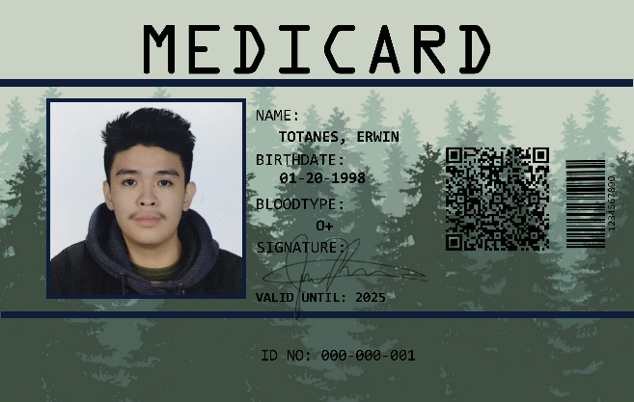

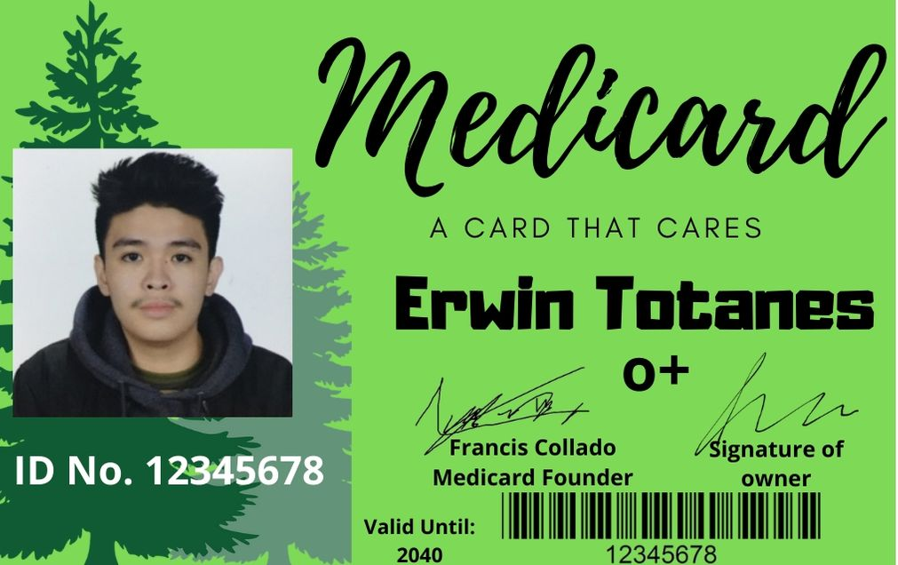

*Proposed Design 1 (Front) Proposed Design 2 (Front)*

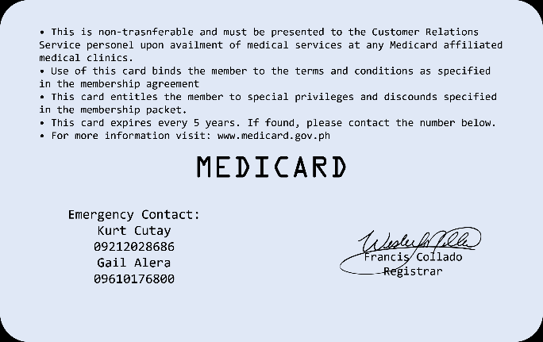



*Proposed Design 1 (Back) Proposed Design 1 (Back)*

The MediCard size will be 3.370 inches wide and 2.125 inches high in order it to fit in wallets of the user. Being compact in size allows the user to bring it wherever and whenever they want. It also have a chip inside, so when the user is going to have his/her check-up the will just tap it to a scanner and all the personal information and medical records will be shown in a desktop. The doctor can update the card using their own record and make it easier for other health care personnel to know the updates.

The first design is colored green because the color green has healing power and is understood to be the most restful and relaxing color for the human eye to view. It also the main color of UC. The design purpose is to make it fun and unique from other ID designs. The font is big so that in case of emergency it will be easier to read.

The second design is colored grey because it symbolizes formal, conservative, and sophisticated. The design purpose is to make it look professional and formal. It has minimal design in order to make it clean and simple because simplicity is beauty. The font is small in order to save more space.